C++ - Language resume

Conteúdo
C++ type system 2
Terminology 2
Specifying variable and function types 2
Fundamental (built-in) types 3
The void type 4
const type qualifier 4
String types 4
User-defined types 4
Pointer types 5
Scope (C++) 5
Hiding Names 6
Hiding class names 6
Hiding names with global scope 7
Modern C++ Programming 7
smart pointers 7
C++ Standard Library smart pointers 9

C++ type system
Some examples of types include int to store integral values, double to store floating-point values (also known as scalar data types), or the Standard Library class std::basic_string to store text. You can create your own type by defining a class or struct.

Terminology
Variable: The symbolic name of a quantity of data so that the name can be used to access the data it refers to throughout the scope of the code where it is defined. In C++, variable is generally used to refer to instances of scalar data types, whereas instances of other types are usually called objects.
Object: For simplicity and consistency, this article uses the term object to refer to any instance of a class or structure, and when it is used in the general sense includes all types, even scalar variables.
POD type (plain old data): This informal category of data types in C++ refers to types that are scalar (see the Fundamental types section) or are POD classes. A POD class has no static data members that aren’t also PODs, and has no user-defined constructors, user-defined destructors, or user-defined assignment operators. Also, a POD class has no virtual functions, no base class, and no private or protected non-static data members. POD types are often used for external data interchange, for example with a module written in the C language (which has POD types only).

Specifying variable and function types
C++ is a strongly typed language and it is also statically-typed; every object has a type and that type never changes (not to be confused with static data objects). When you declare a variable in your code, you must either specify its type explicitly, or use the auto keyword to instruct the compiler to deduce the type from the initializer.
When you declare a function in your code, you must specify the type of each argument and its return value, or void if no value is returned by the function. The exception is when you are using function templates, which allow for arguments of arbitrary types.
After you first declare a variable, you cannot change its type at some later point. However, you can copy the variable’s value or a function’s return value into another variable of a different type. Such operations are called type conversions, which are sometimes necessary but are also potential sources of data loss or incorrectness.
When you declare a variable of POD type, we strongly recommend you initialize it, which means to give it an initial value. Until you initialize a variable, it has a "garbage" value that consists of whatever bits happened to be in that memory location previously. This is an important aspect of C++ to remember, especially if you are coming from another language that handles initialization for you. When declaring a variable of non-POD class type, the constructor handles initialization.
The following example shows some simple variable declarations with some descriptions for each. The example also shows how the compiler uses type information to allow or disallow certain subsequent operations on the variable.
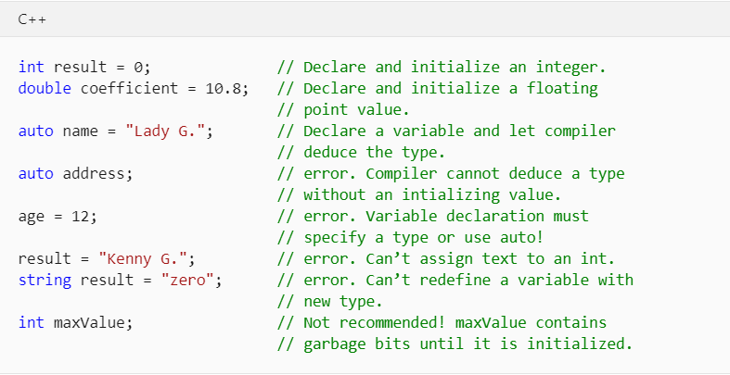

Fundamental (built-in) types
Unlike some languages, C++ has no universal base type from which all other types are derived. The language includes many fundamental types, also known as built-in types. This includes numeric types such as int, double, long, bool, plus the char and wchar_t types for ASCII and UNICODE characters, respectively.
Most integral fundamental types (except bool, double, wchar_t, and related types) all have unsigned versions, which modify the range of values that the variable can store.
For example, an int, which stores a 32-bit signed integer, can represent a value from -2,147,483,648 to 2,147,483,647. An unsigned int, which is also stored as 32-bits, can store a value from 0 to 4,294,967,295. The total number of possible values in each case is the same; only the range is different.
The following table lists the most frequently used fundamental types, and their sizes in the Microsoft C++ implementation:
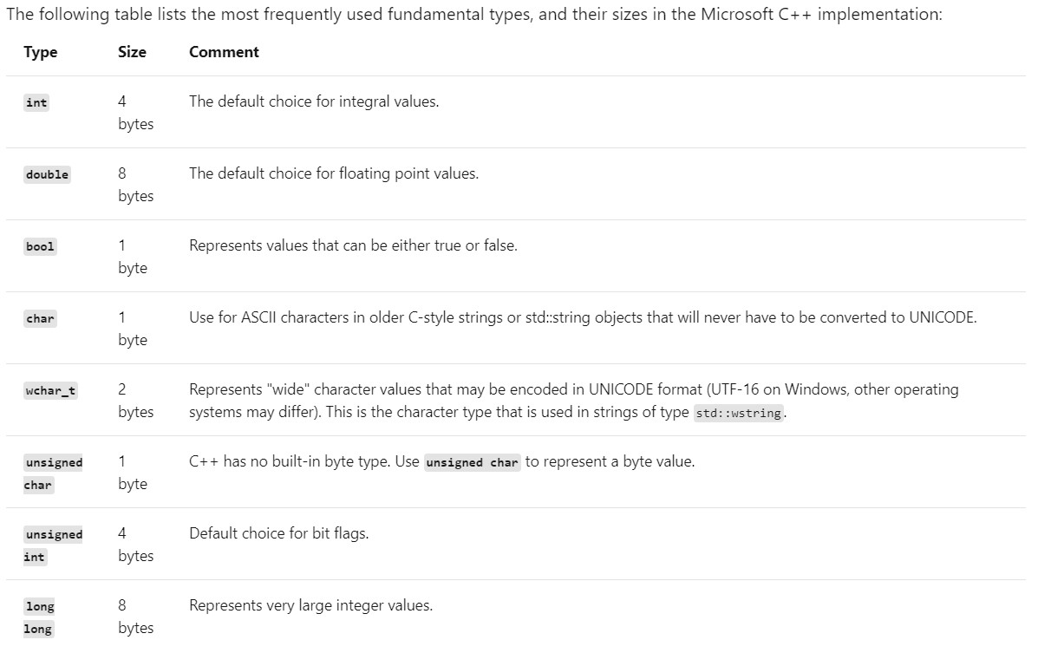

The void type
The void type is a special type; you cannot declare a variable of type void, but you can declare a variable of type void * (pointer to void), which is sometimes necessary when allocating raw (un-typed) memory.
However, pointers to void are not type-safe and generally their use is strongly discouraged in modern C++.
In a function declaration, a void return value means that the function does not return a value; this is a common and acceptable use of void.
While the C language required functions that have zero parameters to declare void in the parameter list,
for example, fou(void),
this practice is discouraged in modern C++ and should be
declared fou()

const type qualifier
Any built-in or user-defined type may be qualified by the const keyword.
Additionally, member functions may be const-qualified and even const-overloaded.
The value of a const type cannot be modified after it is initialized.
The const qualifier is used extensively in function and variable declarations and "const correctness" is an important concept in C++; essentially it means to use const to guarantee, at compile time, that values are not modified unintentionally.

String types
Strictly speaking, the C language has no built-in string type; char and wchar_t store single characters - you must declare an array of these types to approximate a string, adding a terminating null value (for example, ASCII '\0') to the array element one past the last valid character (also called a C-style string).
C-style strings required much more code to be written or the use of external string utility library functions.
But in modern C++, we have the Standard Library types:
std::string (for 8-bit char-type character strings)
std::wstring (for 16-bit wchar_t-type character strings).
These C++ Standard Library containers can be thought of as native string types because they are part of the standard libraries that are included in any compliant C++ build environment. Simply use the #include <string> directive to make these types available in your program.

User-defined types
When you define a class, struct, union, or enum, that construct is used in the rest of your code as if it were a fundamental type. It has a known size in memory, and certain rules about how it can be used apply to it for compile-time checking and, at runtime, for the life of your program. The primary differences between the fundamental built-in types and user-defined types are as follows:
- The compiler has no built-in knowledge of a user-defined type. It learns of the type when it first encounters the definition during the compilation process.
- You specify what operations can be performed on your type, and how it can be converted to other types, by defining (through overloading) the appropriate operators, either as class members or non-member functions.

Pointer types
Dating back to the earliest versions of the C language, C++ continues to let you declare a variable of a pointer type by using the special declarator * (asterisk). A pointer type stores the address of the location in memory where the actual data value is stored.
In modern C++, these are referred to as raw pointers, and are accessed in your code through special operators * (asterisk) or -> (dash with greater-than). This is called dereferencing, and which one that you use depends on whether you are dereferencing a pointer to a scalar or a pointer to a member in an object.
Working with pointer types has long been one of the most challenging and confusing aspects of C and C++ program development.
This section outlines some facts and practices to help use raw pointers if you want to, but in modern C++ it’s no longer required (or recommended) to use raw pointers for object ownership at all, due to the evolution of the smart pointer (discussed more at the end of this section).
It is still useful and safe to use raw pointers for observing objects, but if you must use them for object ownership, you should do so with caution and very careful consideration of how the objects owned by them are created and destroyed.

Scope (C++)
When you declare a program element such as a class, function, or variable, its name can only be "seen" and used in certain parts of your program. The context in which a name is visible is called its scope. For example, if you declare a variable x within a function, x is only visible within that function body.
For automatic non-static variables, scope also determines when they are created and destroyed in program memory.
There are six kinds of scope:
- Global scope A global name is one that is declared outside of any class, function, or namespace. However, in C++ even these names exist with an implicit global namespace. The scope of global names extends from the point of declaration to the end of the file in which they are declared. For global names, visibility is also governed by the rules of linkage which determine whether the name is visible in other files in the program.
- Namespace scope A name that is declared within a namespace, outside of any class or enum definition or function block, is visible from its point of declaration to the end of the namespace. A namespace may be defined in multiple blocks across different files.
- Local scope A name declared within a function or lambda, including the parameter names, have local scope. They are often referred to as "locals". They are only visible from their point of declaration to the end of the function or lambda body. Local scope is a kind of block scope, which is discussed later in this article.
- Class scope Names of class members have class scope, which extends throughout the class definition regardless of the point of declaration. Class member accessibility is further controlled by the public, private, and protected keywords. Public or protected members can be accessed only by using the member-selection operators (. or ->) or pointer-to-member operators (.* or ->*).
- Statement scope Names declared in a for, if, while, or switch statement are visible until the end of the statement block.
- Function scope A label has function scope, which means it is visible throughout a function body even before its point of declaration. Function scope makes it possible to write statements like goto cleanup before the cleanup label is declared.

Hiding Names
You can hide a name by declaring it in an enclosed block.
In the following figure, i is redeclared within the inner block, thereby hiding the variable associated with i in the outer block scope.
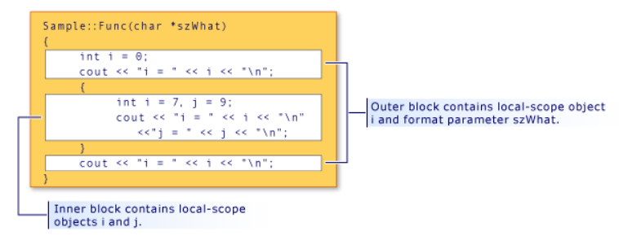

Hiding class names
You can hide class names by declaring a function, object or variable, or enumerator in the same scope. However, the class name can still be accessed when prefixed by the keyword class.
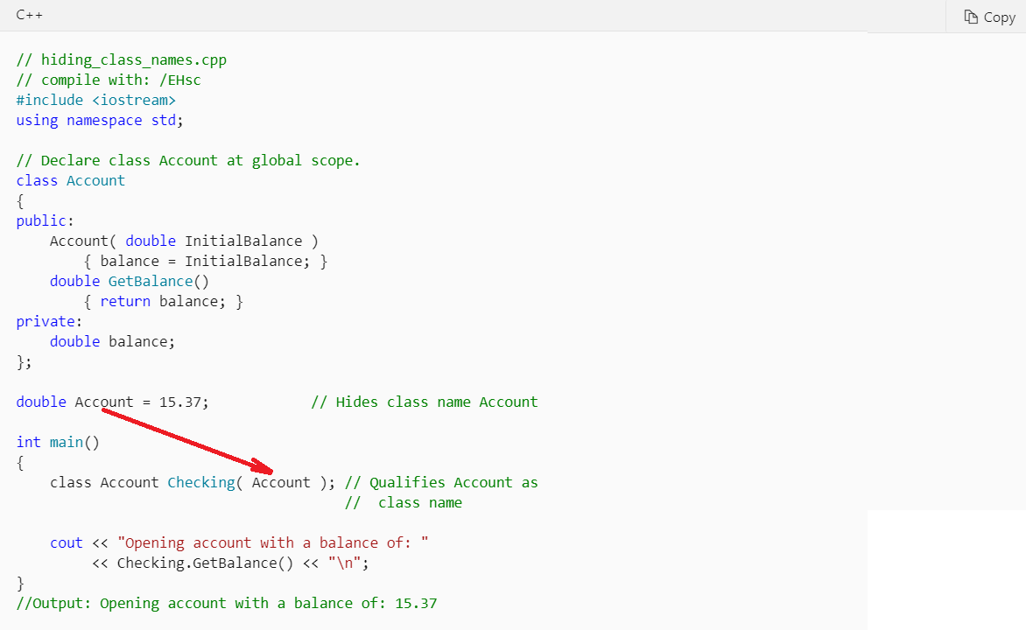
Any place the class name (Account) is called for, the keyword class must be used to differentiate it from the global-scoped variable Account.
This rule does not apply when the class name occurs on the left side of the scope-resolution operator (::).
Names on the left side of the scope-resolution operator are always considered class names.

Hiding names with global scope
You can hide names with global scope by explicitly declaring the same name in block scope. However, global-scope names can be accessed using the scope-resolution operator (::).

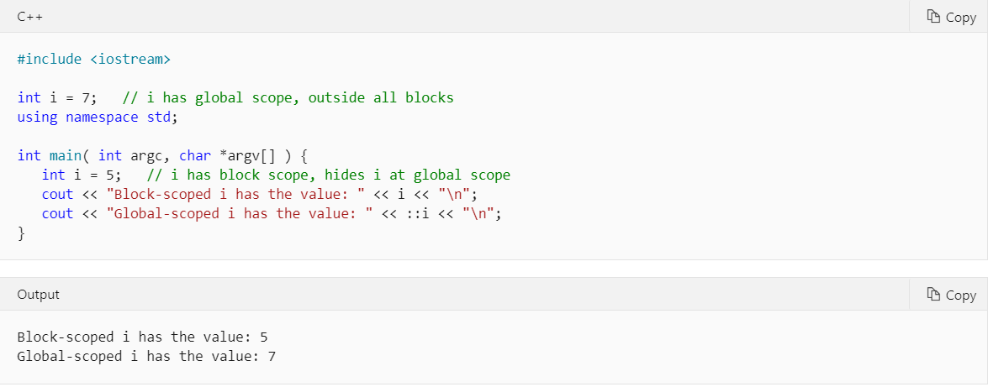

Modern C++ Programming

smart pointers
Smart pointers are defined in the std namespace in the <memory> header file.
They are crucial to the RAII or Resource Acquisition Is Initialization programming idiom.
The main goal of this idiom is to ensure that resource acquisition occurs at the same time that the object is initialized, so that all resources for the object are created and made ready in one line of code. In practical terms, the main principle of RAII is to give ownership of any heap-allocated resource—for example, dynamically-allocated memory or system object handles—to a stack-allocated object whose destructor contains the code to delete or free the resource and also any associated cleanup code.
In most cases, when you initialize a raw pointer or resource handle to point to an actual resource, pass the pointer to a smart pointer immediately.
In modern C++, raw pointers are only used in small code blocks of limited scope, loops, or helper functions where performance is critical and there is no chance of confusion about ownership.
The following example compares a raw pointer declaration to a smart pointer declaration.
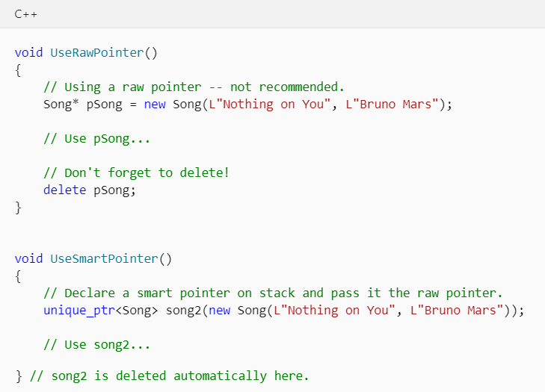
As shown in the example, a smart pointer is a class template that you declare on the stack, and initialize by using a raw pointer that points to a heap-allocated object. After the smart pointer is initialized, it owns the raw pointer.
This means that the smart pointer is responsible for deleting the memory that the raw pointer specifies. The smart pointer destructor contains the call to delete, and because the smart pointer is declared on the stack, its destructor is invoked when the smart pointer goes out of scope, even if an exception is thrown somewhere further up the stack.
The following example shows how a unique_ptr smart pointer type from the C++ Standard Library could be used to encapsulate a pointer to a large object.
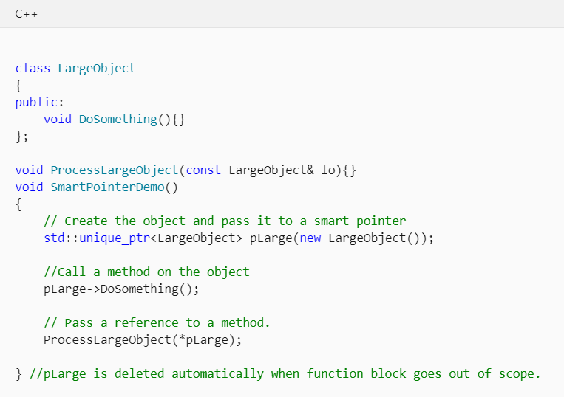
Smart pointers are designed to be as efficient as possible both in terms of memory and performance. For example, the only data member in unique_ptr is the encapsulated pointer. This means that unique_ptr is exactly the same size as that pointer, either four bytes or eight bytes. Accessing the encapsulated pointer by using the smart pointer overloaded * and -> operators is not significantly slower than accessing the raw pointers directly.
Smart pointers have their own member functions, which are accessed by using "dot" notation.
For example, some C++ Standard Library smart pointers have a reset member function that releases ownership of the pointer. This is useful when you want to free the memory owned by the smart pointer before the smart pointer goes out of scope, as shown in the following example.
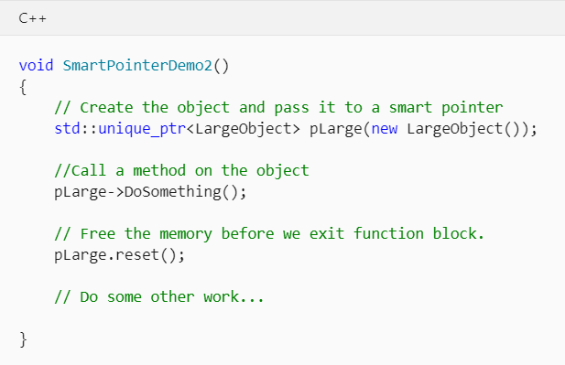

C++ Standard Library smart pointers
Use these smart pointers as a first choice for encapsulating pointers to plain old C++ objects (POCO).
- unique_ptr
Allows exactly one owner of the underlying pointer. Use as the default choice for POCO unless you know for certain that you require a shared_ptr. Can be moved to a new owner, but not copied or shared. Replaces auto_ptr, which is deprecated. Compare to boost::scoped_ptr. unique_ptr is small and efficient; the size is one pointer and it supports rvalue references for fast insertion and retrieval from C++ Standard Library collections. Header file: <memory>. For more information, see How to: Create and Use shared_ptr Instances and shared_ptr Class.
- shared_ptr
Reference-counted smart pointer. Use when you want to assign one raw pointer to multiple owners, for example, when you return a copy of a pointer from a container but want to keep the original. The raw pointer is not deleted until all shared_ptr owners have gone out of scope or have otherwise given up ownership. The size is two pointers; one for the object and one for the shared control block that contains the reference count. Header file: <memory>. For more information, see How to: Create and Use shared_ptr Instances and shared_ptr Class.
- weak_ptr
Special-case smart pointer for use in conjunction with shared_ptr. A weak_ptr provides access to an object that is owned by one or more shared_ptr instances, but does not participate in reference counting. Use when you want to observe an object, but do not require it to remain alive. Required in some cases to break circular references between shared_ptr instances. Header file: <memory>. For more information, see How to: Create and Use weak_ptr Instances and weak_ptr Class.

